# Cloud Lab 6

Installing Knative Functions

My first step was to install func and the Knative plugins

Creating A Function

I created a function through the CLI using this command



Here I am running it on my machine using my docker account.

Here I am invoking the function and you can see the response hello world

Then I built the function using my docker account

Deploying a Knative Service:

Here I am creating the service and deploying it to port 8080

AutoScaling:

Here is the service responding

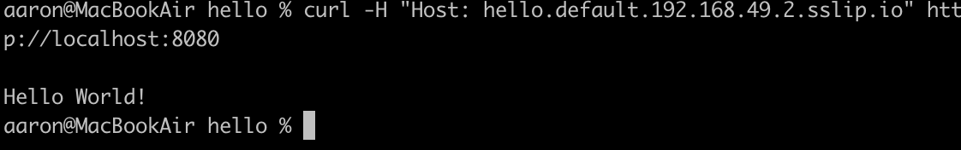

Here we can see the pods scaling to 0 when they get no traffic

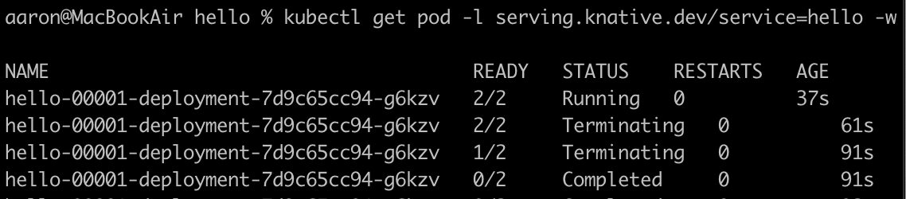

Here we can see the changed service running

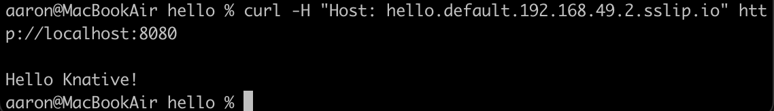

Here are the existing revisions:

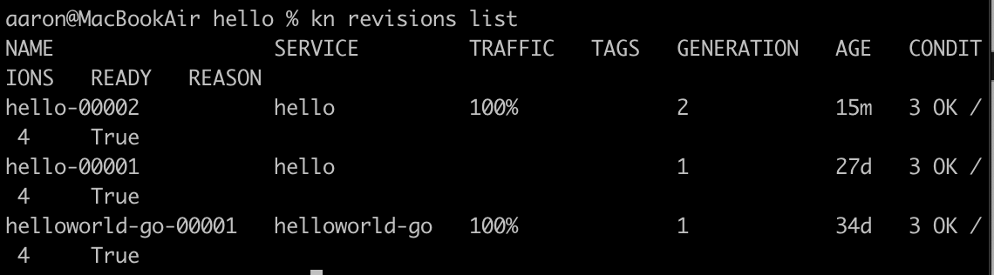

Here we can see the traffic split between the two revisions

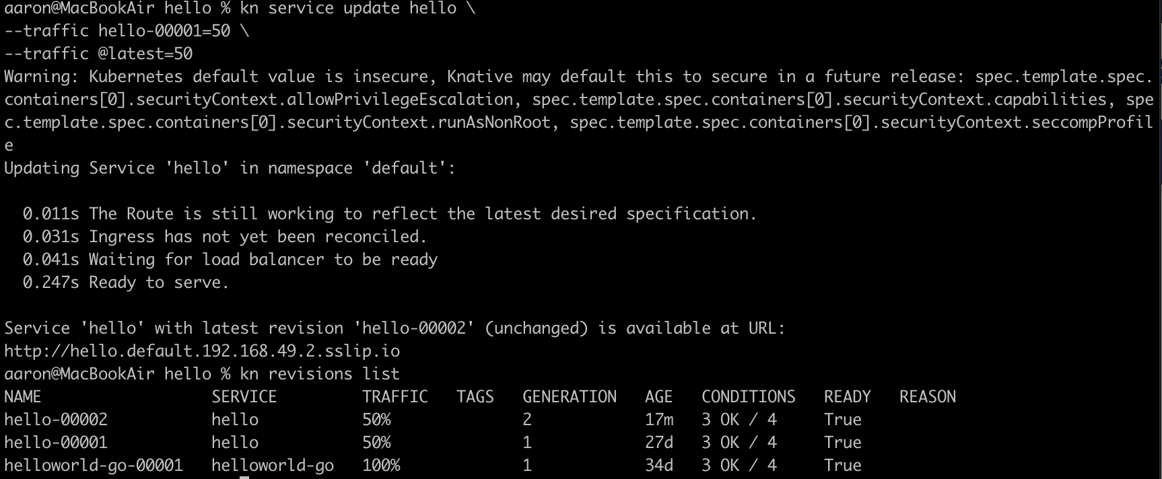

Using Knative service as a source:

Here I am creating the service

Then I created a sinkBinding



This is the cloud events player

This is me sending a test event

Here I am creating a trigger



Here we can see the trigger being created and seen on the cloud events player.

